The **IUSS Conference on Sodic Soil Reclamation**, which is scheduled to take place in Sept. 17-19 in Changchun, China, is postponed to May 10 - 12, 2021 due to the pandemic.

FIRST ANNOUNCEMENT

**First IUSS Conference on Sodic Soil Reclamation**

May 10 - 12, 2021, CHANGCHUN, CHINA

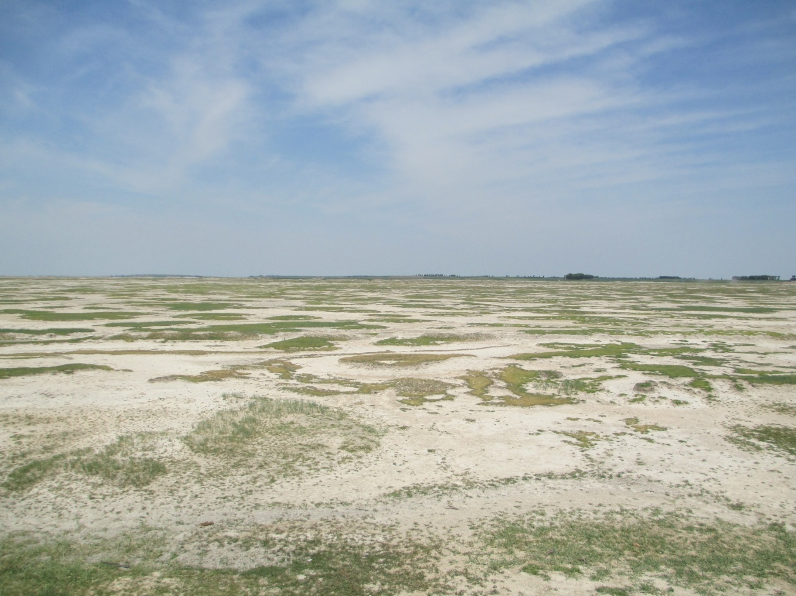

**OVERVIEW**

This conference will focus on the key scientific issues of sodic soil reclamation, face the theoretical innovation of soil sodificaton and improvement of sodic soil management. It will build a communication platform for scholars, enterprises and decision-makers, exchange the latest scientific frontiers through a variety of forms such as academic reports, posters and seminars. It provides useful references for the improvement and utilization of sodic land in different regions of the world.

The conference will be jointly organized by the International Union of Soil Sciences (IUSS), the Chinese Academy of Sciences (CAS) and the People’s Government of Jilin Province, China. It will be hosted by the Northeast Institute of Geography and Agroecology, Chinese Academy of Sciences and the Salt-affected Commission of the Soil Science Society of China. It will be held in Changchun, Jilin Province, China, for a period of three days.

**TOPICS**

* Soil sodification process and mechanism
* Effect of sodification on soil physical and chemical properties
* Monitoring, diagnosis and evaluation of soil sodification
* Irrigation, drainage and salinization
* constraints of soil sodicity on plants
* Plant sodium-tolerance and sodium, salt-tolerance plant breeding
* Principles and techniques for sodic soil improvement
* Comprehensive management of sodic land for agriculture
* Sodic land revegetation

**IMPORTANT DATES**

* First Announcement: Aug. 10, 2020
* Second Announcement: Dec. 12, 2020
* Deadline for abstract submission: Mar. 1, 2021
* Full text of paper: Apr.1, 2021

Selected papers will be considered for publication in a special issue of an international journal.

**FEES**

Registration Fees:

RMB1200yuan for domestic, US$140 for international

Organized by

The International Union of Soil Sciences (IUSS)

The Chinese Academy of Sciences (CAS)

The People’s Government of Jilin Province, China

Organizing committee

Tibor Toth

Zhichun Wang

Jinsong Yang

Changyan Tian

Xiaojing Liu

Manzoor Qadir

**CONTACT**

Zhichun Wang

Ph.D Professor

Northeast Institute of Geography and Agroecology

Chinese Academy of Sciences

Changchun , Jilin Province, China

Phone: +86 043185542240

E-mail: [wangzhichun@iga.ac.cn](mailto:wangzhichun@iga.ac.cn)